Q1. Create the following table using HTML and CSS

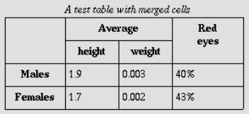

Q2. Make the following page layout and show the values in Alert Box that the user has entered in the first name, last name, and selected in Gender and Hobbies at the button click?

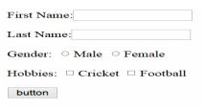

Q3. Create a table having one row and three columns as follows. Write a program in javascript to change the background color of webpage to red if you move your mouse over 1st column. Similarly background color of webpage should be changed to blue if you move your mouse over 2nd column and background color should be green if you move your mouse over 3rd column.

|  |  |  |
| --- | --- | --- |
| Red | Blue | Green |

Q4. Create the following form using various tags used in HTML

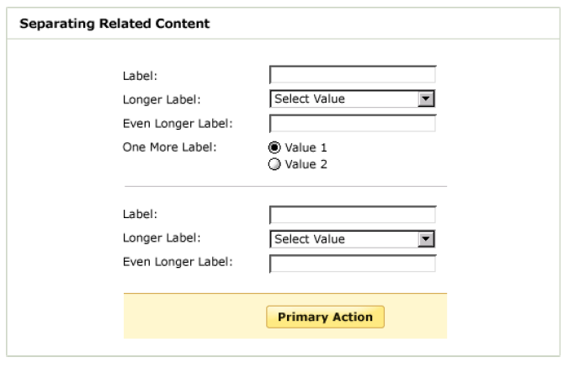

Q5. Create the table shown below:

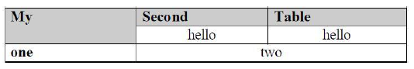

Q6. Create few functions in javascript to calculate the addition, subtraction and multiplication of two numbers entered by the user in the textfields on the click of a ADD, SUB and MUL button and also show the result in the some result Textfield.

Q7. Create the following form using HTML and CSS. Apply validations using JavaScript such that all the following fields are required.

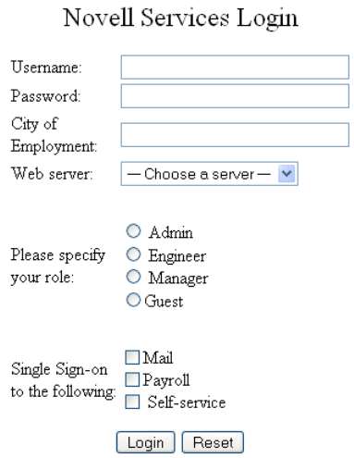

Q8. Create the following table using HTML and CSS

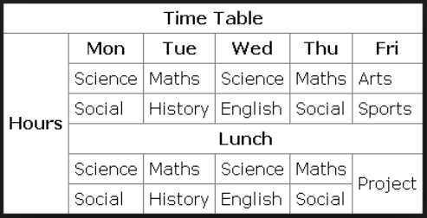

Q9. Create a paragraph and a dropdown list with different color name (any 10 colors). Text color of paragraph should be changed to the color selected by user from the drop down.

Q10. Write a javascript program to show the zoom in and zoom out effect on an textfield using onmouseover and onmouseout event.

Q11. Create two text fields for Rupees and Dollar. Write a program to convert currency from Rupee to Dollar (Enter input in Rupees Texfield and display answer in Dollar Textfield) using javascript when you click on “Calculate” button. Do the same for converting Dollar to Rupee.

Q12. Design the interface of a calculator as follows using HTML and CSS

